|  |  |  |  |  |
| --- | --- | --- | --- | --- |
| Field | Tipe | Length | unique | Keterangan |
| _id | ObjectId | - | unique | Primary key |
| username | String | - | unique | - |
| password | String | - | unique | - |
| email | String | - | - | - |
| role | String | - | - | - |
| member_at | Date | - | - | - |

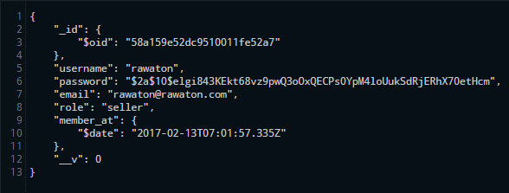

|  |  |  |  |  |
| --- | --- | --- | --- | --- |
| Field | Tipe | Length | Unique | Keterangan |
| _id | ObjectId | - | unique | Primary key |
| id_user | ObjectId | - | unique | Foreign Key |
| no_telp_kantor | String | - | unique | - |
| nama_toko | String | - | - | - |
| alamat_jalan | String | - | - | - |
| alamat_kecamatan | String | - | - | - |
| alamat_kota | String | - | - | - |
| alamat_kabupaten | String | - | - | - |
| alamat_provinsi | String | - | - | - |
| alamat_kode_pos | String | - | - | - |

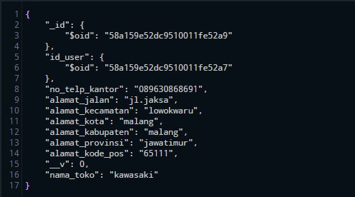

|  |  |  |  |  |
| --- | --- | --- | --- | --- |
| Field | Tipe | Length | Unique | Keterangan |
| _id | ObjectId | - | unique | Primary key |
| id_user | ObjectId | - | unique | Foreign Key |
| gambar_user | String | - | - | - |
| nama_user | String | - | - | - |
| no_telp_user | String | - | - | - |

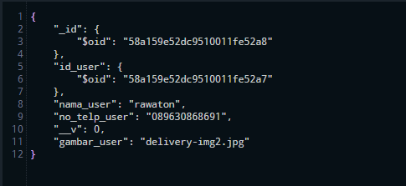

|  |  |  |  |  |
| --- | --- | --- | --- | --- |
| Field | Tipe | Length | Unique | Keterangan |
| _id | ObjectId | - | unique | Primary key |
| id_User | ObjectId | - | unique | Foreign Key |
| name_product | String | - | - | - |
| category_product | String | - | - | - |
| price_product | Number | - | - | - |
| quantity_product | Number | - | - | - |
| description_product | String | - | - | - |
| picture_product | String | - | - | - |
| created_at | Date | - | - | - |

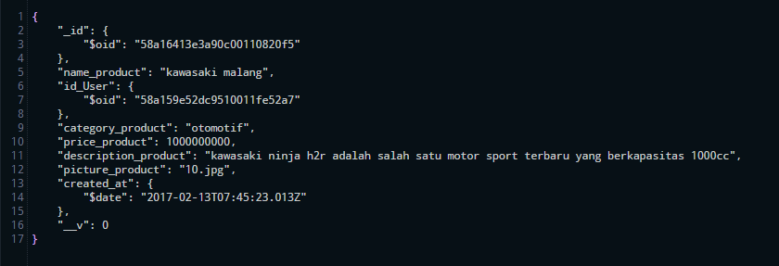

|  |  |  |  |  |
| --- | --- | --- | --- | --- |
| Field | Tipe | Length | Unique | Keterangan |
| _id | ObjectId | - | unique | Primary key |
| id_user | ObjectId | - | unique | Foreign Key |
| status | String | - | - | - |
| offline | Date | - | - | - |
| online | Date | - | - | - |

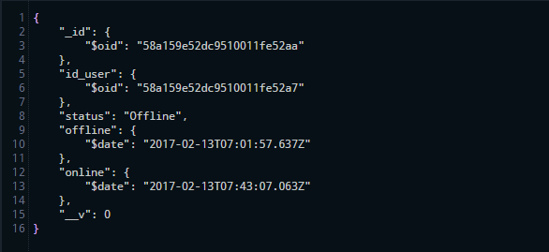

|  |  |  |  |  |
| --- | --- | --- | --- | --- |
| Field | Tipe | Length | Unique | Keterangan |
| _id | ObjectId | - | unique | Primary key |
| id_user | ObjectId | - | unique | Foreign Key |
| id_seller | ObjectId | - | unique | Foreign Key |
| tanggal_buat | Date | - | - | - |
| status | String | - | - | - |
| status_pembayaran | String | - | - | - |
| status_pengiriman | String | - | - | - |
| total_harga | Number | - | - | - |
| Tanggal_pembayaran | Date | - | - | - |
| Tanggal_pengiriman | Date | - | - | - |
| Tanggal_selesai | Date | - | - | - |

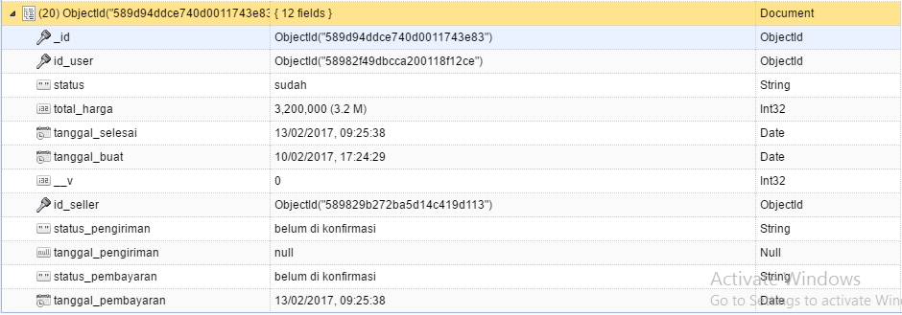

|  |  |  |  |  |
| --- | --- | --- | --- | --- |
| Field | Tipe | Length | Unique | Keterangan |
| _id | ObjectId | - | unique | Primary key |
| Id_pembelian | ObjectId | - | unique | Foreign Key |
| id_buyer | ObjectId | - | unique | Foreign Key |
| no_telp_kantor | String | - | unique | - |
| nama_toko | String | - | - | - |
| alamat_jalan_penerima | String | - | - | - |
| alamat_kecamatan_penerima | String | - | - | - |
| alamat_kota_penerima | String | - | - | - |
| alamat_kabupaten_penerima | String | - | - | - |
| alamat_provinsi_penerima | String | - | - | - |
| alamat_kode_pos_penerima | String | - | - | - |

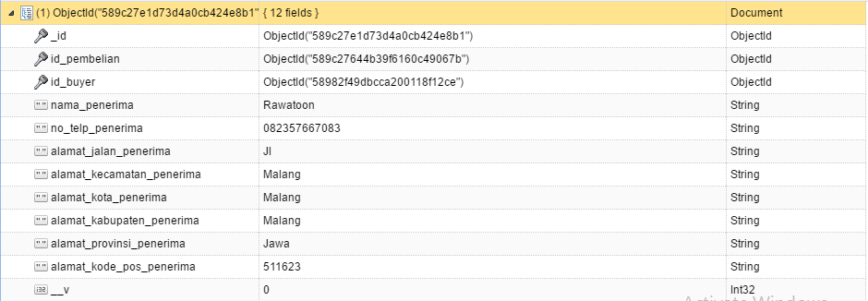

|  |  |  |  |  |
| --- | --- | --- | --- | --- |
| Field | Tipe | Length | Unique | Keterangan |
| _id | ObjectId | - | unique | Primary key |
| id_cart | ObjectId | - | unique | Foreign Key |
| id_product | ObjectId | - | unique | Foreign Key |
| id_seller | ObjectId | - | unique | Foreign key |
| nama_product | String | - | unique | - |
| nama_seller | String | - | - | - |
| gambar_item | String | - | - | - |
| jumlah | Number | - | - | - |
| harga_nego | Number | - | - | - |
| tanggal_pesan | Date | - | - | - |

